ShopEz
Full Stack MERN E-Commerce Application

Project Technical Documentation

Developed by: INAPAKUTHIKA BHARATH VARMA
Email: bharathvarma906@gmail.com
Team ID: Date: 18 June 2026


Introduction
Project Title: ShopEz
Developer: INAPAKUTHIKA BHARATH VARMA (Solo Project)

ShopEz represents a sophisticated, end-to-end e-commerce environment engineered to provide consumers with a fluid and modern retail journey. Built upon the high-performance MERN stack (comprising MongoDB, Express.js, React.js, and Node.js), the application effectively links users to a diverse product catalog through a highly responsive and user-centric interface.


Purpose: The primary objective of ShopEz is to establish a secure, scalable platform for digital commerce. It facilitates intuitive product discovery, streamlined cart management, and safe transaction processing. Furthermore, it incorporates a specialized administrative layer designed for precise inventory oversight and lifecycle management of customer orders.

Key Features:
- User Module: Includes secure account registration, JWT-based login mechanisms, and personalized user profiles.
- Product Module: Features structured browsing across categories (Men, Women, Kids), alongside advanced search and filtering capabilities.
- Cart & Checkout: Enables dynamic, real-time shopping cart updates and supports Cash on Delivery (COD) as a primary payment method.
- Admin Dashboard: A comprehensive control center for managing product inventory, analyzing sales, and updating order fulfillment statuses.



Frontend (React.js):
The client-side is constructed using a Component-Based Architecture to ensure modularity and code reusability. Application state is managed efficiently via the React Context API or local state hooks. Navigation across the application is handled by React Router DOM, facilitating a Single Page Application (SPA) experience with client-side routing.

Backend (Node.js & Express.js):
The server-side follows an MVC-inspired design to provide a robust RESTful API. Express.js manages the routing logic, while custom middleware functions handle security, user authentication, and data validation. The backend serves structured JSON responses to interact seamlessly with the React frontend.

Database (MongoDB):
A NoSQL document-oriented database is utilized for flexible and high-speed data storage. The primary data collections include:
- Users: Manages secure credentials, contact details, and hierarchical roles (User vs. Admin).
- Products: Stores comprehensive metadata such as titles, descriptions, categories, pricing, and stock levels.
- Orders: Tracks complete transaction histories, item references, and logistical shipping statuses.



Prerequisites:
- Node.js (Version 18.x or newer)
- Package Managers: NPM or Yarn
- MongoDB Community Server (Configured to run on local port 27017)

Installation Steps:

Repository Initialization:
https://github.com/bharathvarma906/SHOPEZ_PROJECT.git

Server Configuration:
cd server && npm install

Client Configuration:
cd client && npm install
- Environment Setup: Create a .env file within the server root directory with the following variables:

PORT=5000
MONGO_URI=mongodb://localhost:27017/shopez JWT_SECRET=your_secure_secret_key



Directory | Description
/server/models | Data definitions using Mongoose schemas for Users, Products, and Orders.
/server/routes | Definitions for API endpoints and their corresponding logic handlers.
/client/src/ components | Reusable UI elements like Header, Footer, and Product Cards.
/client/src/pages | High-level view components (Home, Product Details, Checkout).



To initialize the application in a local development environment, execute these commands in separate terminal instances:

Backend Service:
cd server && npm run dev

Frontend Application:
cd client && npm start
HTTP  Method | Endpoint | Functionality
POST | /api/users/ login | Validates user credentials and issues a JWT token.
GET | /api/products | Retrieves the product list with support for filtering criteria.
POST | /api/orders | Registers a new COD transaction (Authorized Access).



The ShopEz application employs JSON Web Tokens ( JWT) for secure, stateless user sessions. Upon successful login, the server issues a signed token which the browser stores in LocalStorage or Cookies. This token is subsequently included in the 'Authorization' header for all protected requests. Customs middleware intercepts these requests to verify the token and enforce role-based access control, such as restricting access to the administrative dashboard.




The user interface adheres to a clean, minimalist design standard to prioritize ease of use. Key UI components include a sticky responsive navbar, grid-based product displays, and a streamlined checkout workflow. The design incorporates visual placeholders for high-resolution images and banners to ensure a professional aesthetic.

A

structured testing plan was implemented to maintain system integrity:
Unit Testing: focused on verifying the logic of standalone helper functions and data validators.
- Integration Testing: validated that Express API routes successfully communicate with the MongoDB database.
- User Scenarios: Examples include ensuring the system correctly blocks adding out-of-stock items to the cart and displays appropriate warnings.



Source Code & Demo Link: https://github.com/bharathvarma906/SHOPEZ.git

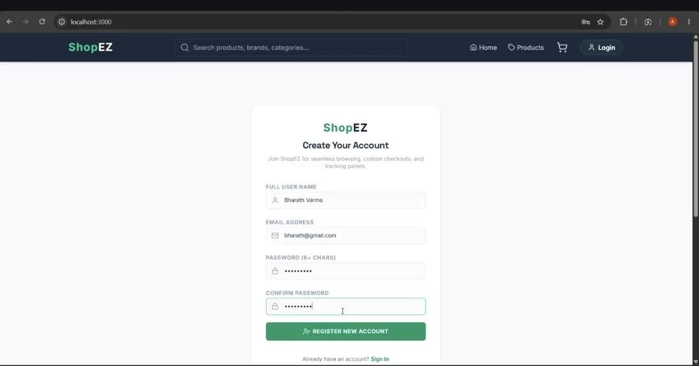

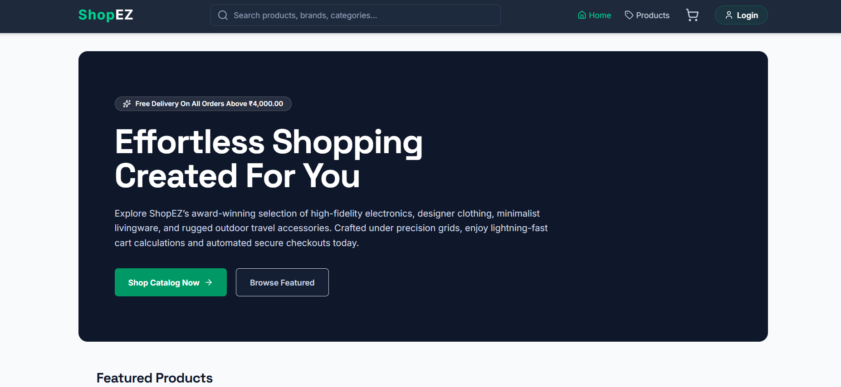
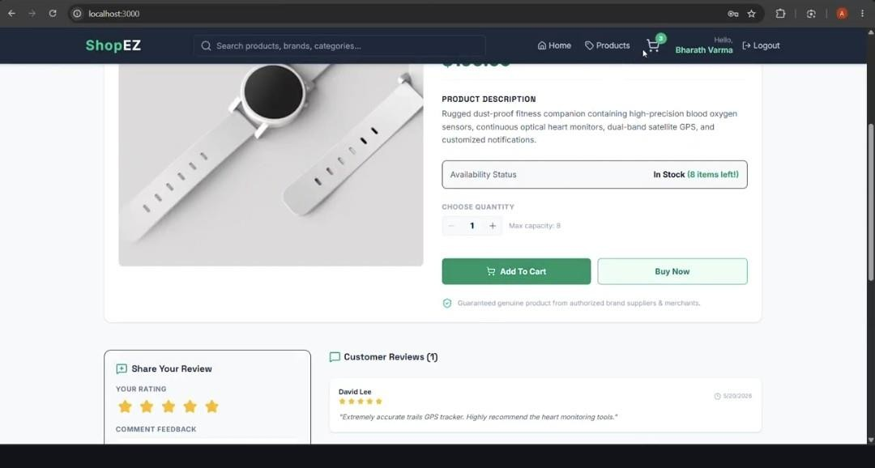

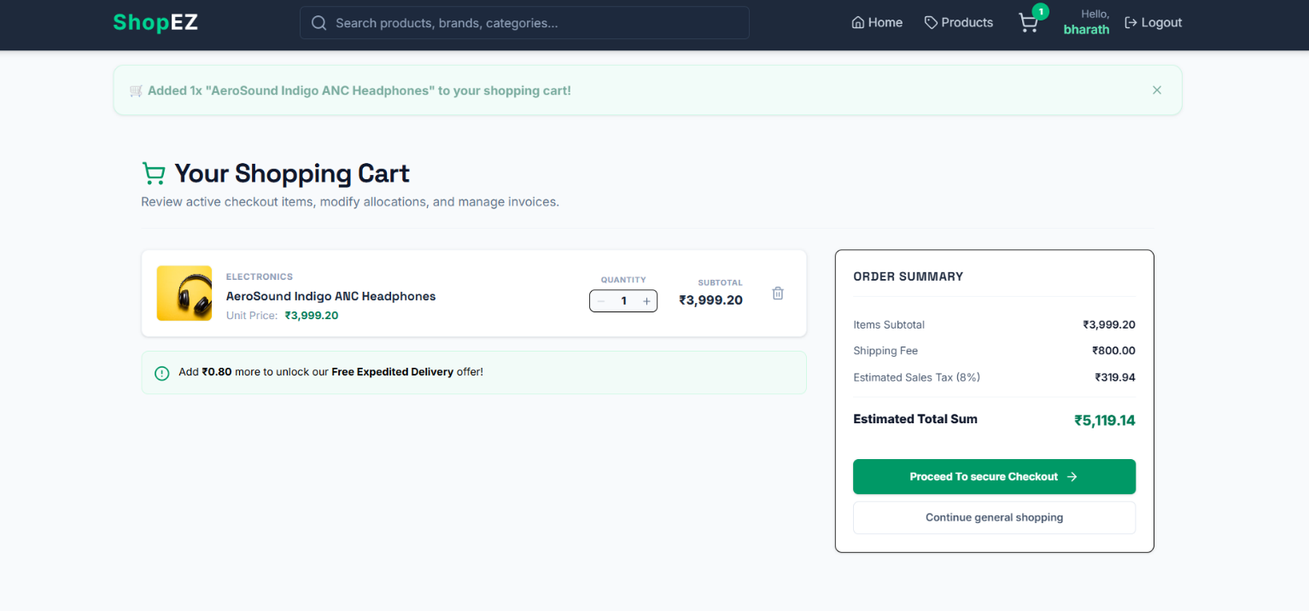

- Resetting client-side filters may occasionally require a manual browser refresh.
- Handling very large image files directly in MongoDB may affect load times; transitioning to a dedicated service like Cloudinary is planned.




- Integration of digital payment gateways such as Stripe or Razorpay.
- Development of an AI-driven system for personalized product suggestions.
- Enhancing the app into a Progressive Web App (PWA) for improved offline capabilities.

